Game Design Document

Fill up the following document

1. Write the title of your project.

Archery Game

1. What is the goal of the game?

The goal of the game is to hit a bullseye.

1. Write a brief story of your game.

The game impersonates reaching your goal even with the difficulties in between.

1. Which are the playing characters of this game?

* Playing characters are the ones who respond to the user based on the input from the user.
* Cars, monkeys, dinos, wizards, etc., are the playing characters in the game.

|  |  |  |
| --- | --- | --- |
| Number | Character Name | What can this character do? |
| 1 | Arrow | User controls the arrow to hit the archery board and score points. |

1. Which are the Non-Playing Characters of this game?

* Non-Playing characters are the ones that don't have an action or behavior when the user interacts with the game.
* Hurdles, stones, bananas, coins, etc., are non-playing characters in the game.

|  |  |  |
| --- | --- | --- |
| Number | Character Name | What can this character do? |
| 1 | Archery Board | The board moves making it harder to hit a bullseye. |
| 2 | Coins | Increase points. |

Draw your imagination of this game. What does this game look like?

* Draw the game either on your computer or on paper.
* Add images of the game scenes to show each of the playing and non-playing characters at least once.

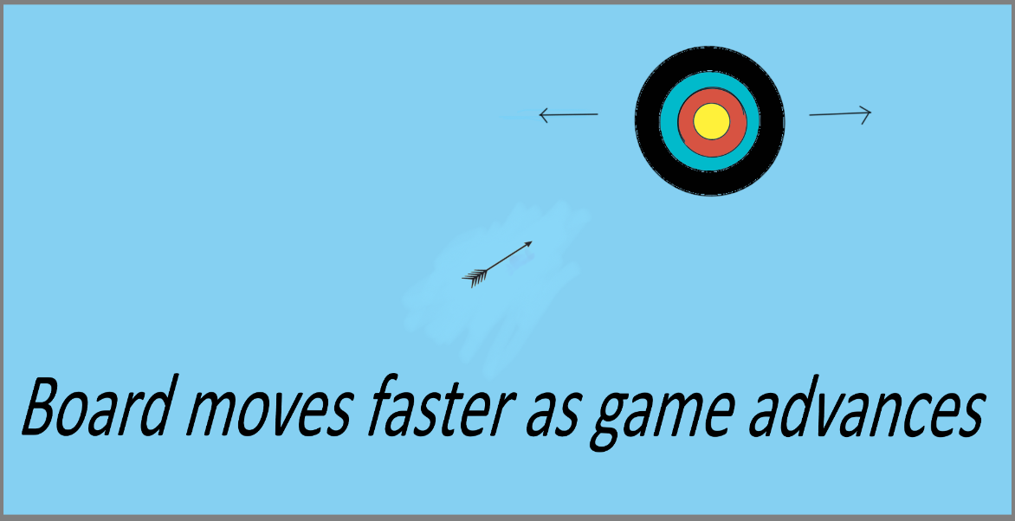

How do you plan to make your game engaging?

The archery board moves side by side making it harder to hit the board. There will be coins spawning randomly which will help increase points.